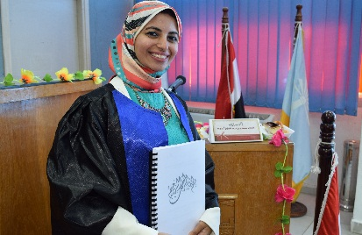
NAME: Hadeer Mamdouh Abdelaziz Ahmed Radwan
Job Title: Assistant Lecturer at Pharmaceutics Department

Home address: Alexandria , Egypt
Mobile: 01066839985
Email: HadeerM.Abdelaziz@pharm.dmu.edu.eg
Doddamamdouh@gmail.com

Educational Background
2012 | Bachelor degree in Faculty of Pharmacy, Alexandria University, Egypt
2018 | Master degree in Pharmaceutical Sciences (Industrial Pharmacy)
2019 till now | PhD Student in Department of Pharmaceutics, Faculty of Pharmacy, Damanhour University, Egypt

Work Experience
2019 Till Now | Works as Assistant lecturer, Pharmaceutics Department, Faculty of Pharmacy, Damanhour University
2018 to 2019 | Works as Demonstrator, Pharmaceutics Department, Faculty of Pharmacy, Damanhour University
2014 to 2018 | Master Degree Student in Cancer Nanotechnology Research Center (CNRL), Faculty of Pharmacy, Alexandria University
2013 to 2018 | Works as Hospital pharmacist in Alexandria Main University Hospital (AMUH)
2012 to 2014 | Works as Community pharmacist in El Sherif el Tayeby pharmacy in Alexandria

